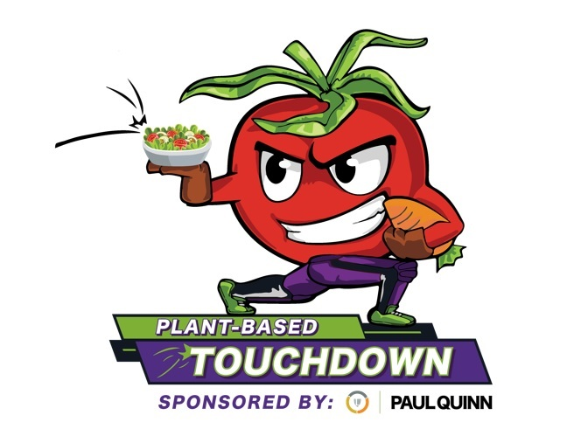

Legends Hospitality at AT&T Stadium, Paul Quinn College Kick-off “Plant-Based Touchdown,” A Campaign Inspiring Fans to Incorporate More Plants Into Their Diet to Counter Prevalence of Diabetes, Heart Disease
ARLINGTON and DALLAS – September 24, 2021 – Legends at AT&T Stadium, Home of the Dallas Cowboys and Paul Quinn College’s WE Over Me Farm have partnered for “Plant-Based Touchdown,” a new culinary campaign focusing on the health benefits and full flavors of fresh produce to inspire African-American, Latino, Native American and all fans to incorporate more plants in their diet, directly combating diabetes, hypertension and other chronic illnesses.
Inspired by game day and using PQC’s WE Over Me Farm’s organic produce grown on the Paul Quinn campus in Southern Dallas, new offerings of plant-based culinary creations developed by Legends Hospitality will be available at concessions on Dallas Cowboys game days during the 2021 NFL season at AT&T Stadium. The healthful, flavorful vegetarian recipes will also be shared with fans cheering on from home.
“Legends at AT&T Stadium has a long standing, heartfelt community connection with the WE Over Me Farm, where organic produce is grown on Paul Quinn’s former football field, a field I used to play on,” said George Wasai, a distinguished alumnus of Paul Quinn College, former Paul Quinn Tigers football player, and Director of Food & Beverage for Legends Hospitality. “We hope to positively impact the wellness and health of the entire North Texas community, and especially those most vulnerable to chronic diseases.”
According to a 2020 CDC Diabetes Statistics Report, there is a prevalence of diagnosed diabetes among people of Hispanic, African American and Native American origin. According to the Journal of the American Heart Association, plant-based diets are associated with a lower risk of cardiovascular disease.
Each Dallas Cowboys game day will feature two special stations on the Upper Concourse where special Plant-Based Touchdown dishes will be available to fans for purchase. Legends at AT&T Stadium culinary talent will be cooking for fans as Paul Quinn College students will be present as Plant Based Touchdown ambassadors and advocates, distributing recipe cards to fans on game day.
The following delicious selections will be served on the menu:
Awesome Plant-Based Burger A hearty Plant Based Burger served on a fresh brioche bun with lettuce, tomato, grilled onion and chipotle aioli. Available at: The Plant-Based/Vegetarian Carts located at sections U411 and U441.
Buffalo Chick’n Nachos Blue corn tortilla chips topped with our all natural jalapeño jack queso and Sweet Earth’s plant-based chicken tossed in buffalo sauce finished off with pickled jalapeños. Available at: The Plant-Based/Vegetarian Carts located at sections U411 and U441.
Touchdown Tots Crispy Tator Tots drizzled with our all-natural jalapeño jack cheese, guacamole, sour cream then topped with Sweet Earth’s plant-based chicken tossed in Cholula Sauce finished off with fresh pico de gallo and fresh lime. Available at: The Plant-Based/Vegetarian Carts located at sections U411 and U441.
Plant-Based Chicken Avocado Wrap Crispy plant-based chicken, fresh avocados, crisp lettuce, topped with creamy ranch and wrapped in a soft tortilla. Available at: The Plant-Based/Vegetarian Carts located at sections U411 and U441.
Plant-Based Chopped Chicken Salad Crisp lettuce and cucumbers, tomatoes, charred corn, plant-based crispy chicken, black beans topped with creamy herb dressing. Available at: The Plant-Based/Vegetarian Carts located at sections U411 and U441.

“Paul Quinn College has a rich 150-year history of going beyond the status quo, challenging societal ideals, and rewriting traditional rules – starting with turning our football field into an organic farm. We have lived out our ethos of “WE Over Me” which puts the needs of the community above our own,” said Dr. Michael J. Sorrell, President of Paul Quinn College. “We are grateful for our 12-year partnership with Legends and fellow Quinnite George Wasai, who shares in our mission of providing underserved, overlooked and under-resourced communities in our city access to quality foods and encouraging them to lead a healthier lifestyle.”
The “Plant-Based Touchdown” campaign will also include the following components fans can enjoy and access from wherever they are cheering:
- Flavorful recipes that are easy to prepare, featuring ingredients that are accessible and affordable.
- An online platform and home for recipe archive and content on a dedicated page on Paul Quinn College's website.
- A vibrant and fun wellness campaign with inspirational and educational posts on WE Over Me Farm, AT&T Stadium, Legends and campaign partner social media channels.
- Cooking segments from Legends at AT&T Stadium leadership featured on the online platform and social channels.
- A grassroots campaign that will share printed recipe cards in community centers, grocery stores and churches in underserved communities.
The Plant Based Touchdown recipes include plant-based chicken and beef proteins as key ingredients in these featured recipes:
- Cheesesteak Vegan Sandwich
- Plant-Based Buffalo Mini-Sliders
- Avocado Plant-Based Chicken Wrap
- Roasted Squash, Walnut and Kale Salad
- Plant-Based Chicken Chopped Salad
- Plant-Based Chicken & Bean Scampi Salad
LINK TO HIGH-RES PHOTOS OF PLANT-BASED TOUCHDOWN MENU 2021-2022 DALLAS COWBOYS NFL SEASON
Legends has purchased fine produce from WE Over Me Farm since 2009 as ingredients in the famous menus at AT&T Stadium for Dallas Cowboys gamedays, as well as major sports and entertainment events and experiences. George Wasai is leading the Plant-Based Touchdown program, working with Legends at AT&T Stadium Executive Chef Marcelo Vasquez and Concessions Chef Heather Fuller.
About AT&T Stadium AT&T Stadium is the largest, most technologically advanced entertainment venue in the world. Designed by HKS and built by Manhattan Construction, the $1.2 billion stadium features two monumental arches, the world’s largest HDTV video board cluster, an expansive retractable roof and the largest retractable end zone doors in the world. Features of the stadium include seating for 80,000 and expandability for up to 100,000, over 300 luxury suites, club seating on multiple levels and the Dallas Cowboys Pro Shop, open to the public year-round. New for fans of all ages for the 2021 season, the Miller Lite® House will provide a new experience while boasting a 70-yard Cowboys turf field featuring field games, four video boards and over 60 television screens, two fantasy football screen walls, over 87,000 outdoor square-footage for event day experiences. The space also features two beer gardens and a walk-in beer cooler. The stadium is also home to a world-class collection of contemporary art, made up of over 92 works of art by 62 established and emerging artists displayed on the walls and in the grand public spaces of the venue. In addition to being the home of the Dallas Cowboys since opening in 2009, the stadium has hosted Super Bowl XLV, the 2010 NBA All Star Game, the annual Goodyear Cotton Bowl Classic, the 2014 NCAA Men’s Final Four, the 2015 inaugural College Football Playoff Championship Game, the 2015 50th Anniversary Academy of Country Music Awards show and WrestleMania 32. The venue has also played host to high school and college football, concerts, championship fights, international soccer matches and other special events. For more information, go to attstadium.com.

About Legends Founded in 2008, Legends is a premium experiences company with six divisions operating worldwide - Global Planning, Global Sales, Hospitality, Global Partnerships, Global Merchandise, and Global Technology Solutions - offering clients and partners a 360-degree service solution platform to elevate their brand and execute their vision. Currently, Legends works with marquee clients across business verticals, including professional sports; collegiate sports; attractions; entertainment; and conventions and leisure. Legends is an industry leader in designing, planning and realizing exceptional experiences in sports and entertainment. For more information, visit www.Legends.net and follow Legends at Facebook, Twitter and Instagram @TheLegendsWay.
.
About Paul Quinn College Paul Quinn College is a private, faith-based, four-year, liberal arts-inspired college that was founded in 1872 by a group of African Methodist Episcopal Church preachers in Austin, Texas. The school’s original purpose was to educate freed slaves and their offspring. Today, we proudly educate students of all races and socio-economic classes under the banner of our institutional ethos, WE over Me. Our mission is to provide a quality, faith-based education that addresses the academic, social, and Christian development of students. Under President Dr. Michael J. Sorrell’s leadership, Paul Quinn has become one of the most innovative and respected small colleges in the nation and now serves as a model for urban higher education. Fortune magazine recognized President Sorrell’s work and the College’s transformation by naming him one of the World’s 50 Greatest Leaders. President Sorrell is also a three-time award winner of HBCU Male President of the Year by HBCU Digest and was named by Time magazine as one of the “31 People Changing the South.”
# # #

Contact:
Fran Gallagher fran@praestarpr.com 214-762-6193

